Report about best devices in PC, best operating system and suitable programming languages.
System Name: Student Gradebook System
- Best Devices
Computers: So that teachers can access the Grade Management System and give grades to students
Laptops: So that Students can study and work on their tasks
Servers: To Store The information of teachers and students and it will contain the database of the Grade Management System

- Best Operating System
Windows: It is simple to use and has direct compatibility with .NET Framework/.NET Framework Core.
Linux: It is free and open source, excellent for servers, and offers strong security features.

- Suitable Programming Languages
C# (.NET / .NET CORE): Famous for desktop and Web Applications and because of its flexibility and Security.
SQL Server: One of the best database languages it will help us in storing the data of the Teachers and Students, etc

Design of an integrated system (Class diagram)

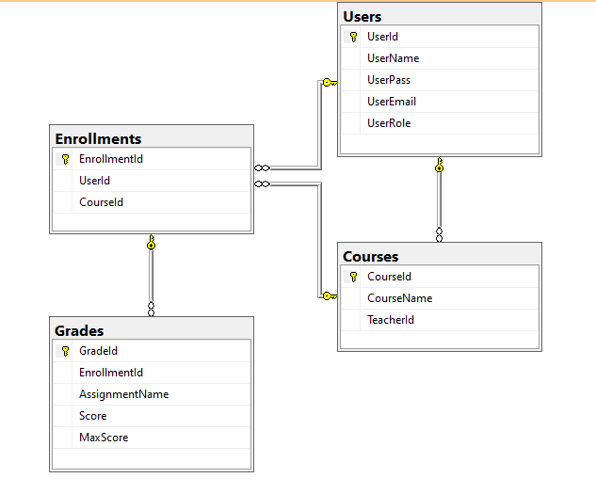

Testing
Test case ID | Test case description | Test Steps | Test Data | Expected Result | Actual Result | Pass/Fail
1 | Testing Login Page Functionality (Valid Username, valid password as Teacher) | Get Username  Get Password  Click login | Username: john_teacher  Password: MathTeach2024! | Login to Grade Management Page | Login to Grade Management Page | Pass
2 | Testing Login Page Functionality (Valid Username, valid password as Student) | Get Username  Get Password  Click login | Username: mike_student  Password: MikePass123$ | Login to the student Page | Program Closed | Fail
3 | Testing Login Page Functionality (Valid Username, valid password as Student) | Get Username  Get Password  Click login | Username: mike_student  Password: MikePass123$ | Login to the student Page | Login to the student Page | Pass
4 | Testing Login Page Functionality (Valid Username, invalid password) | Get Username  Get Password  Click login | Username: mike_student  Password:123 | Error Message User Not Found | Error Message User Not Found | Pass
5 | Testing Login Page Functionality (blank Username, blank password) | Get Username  Get Password  Click login | Username:-  Password:- | Error Message User Not Found | Error Message User Not Found | Pass
6 | Testing Login Page Functionality (Invalid Username, invalid password) | Get Username  Get Password  Click login | Username: mikestudent  Password: MikePass | Error Message User Not Found | Error Message User Not Found | Pass

